Instructions on how to capture logs from Bipac 74xx.

1. Please turn off your Bipac 74xx.
2. Unplug your USB dongle (if have one).
3. Take the serial converter out of the box, (one side serial second side rj-45)
4. Plug the serial connecter up to your PC, insert the rj-45 cable into the serial connecter and the other end of the rj-45 cable to lan port 4 on the Bipac 74xx.

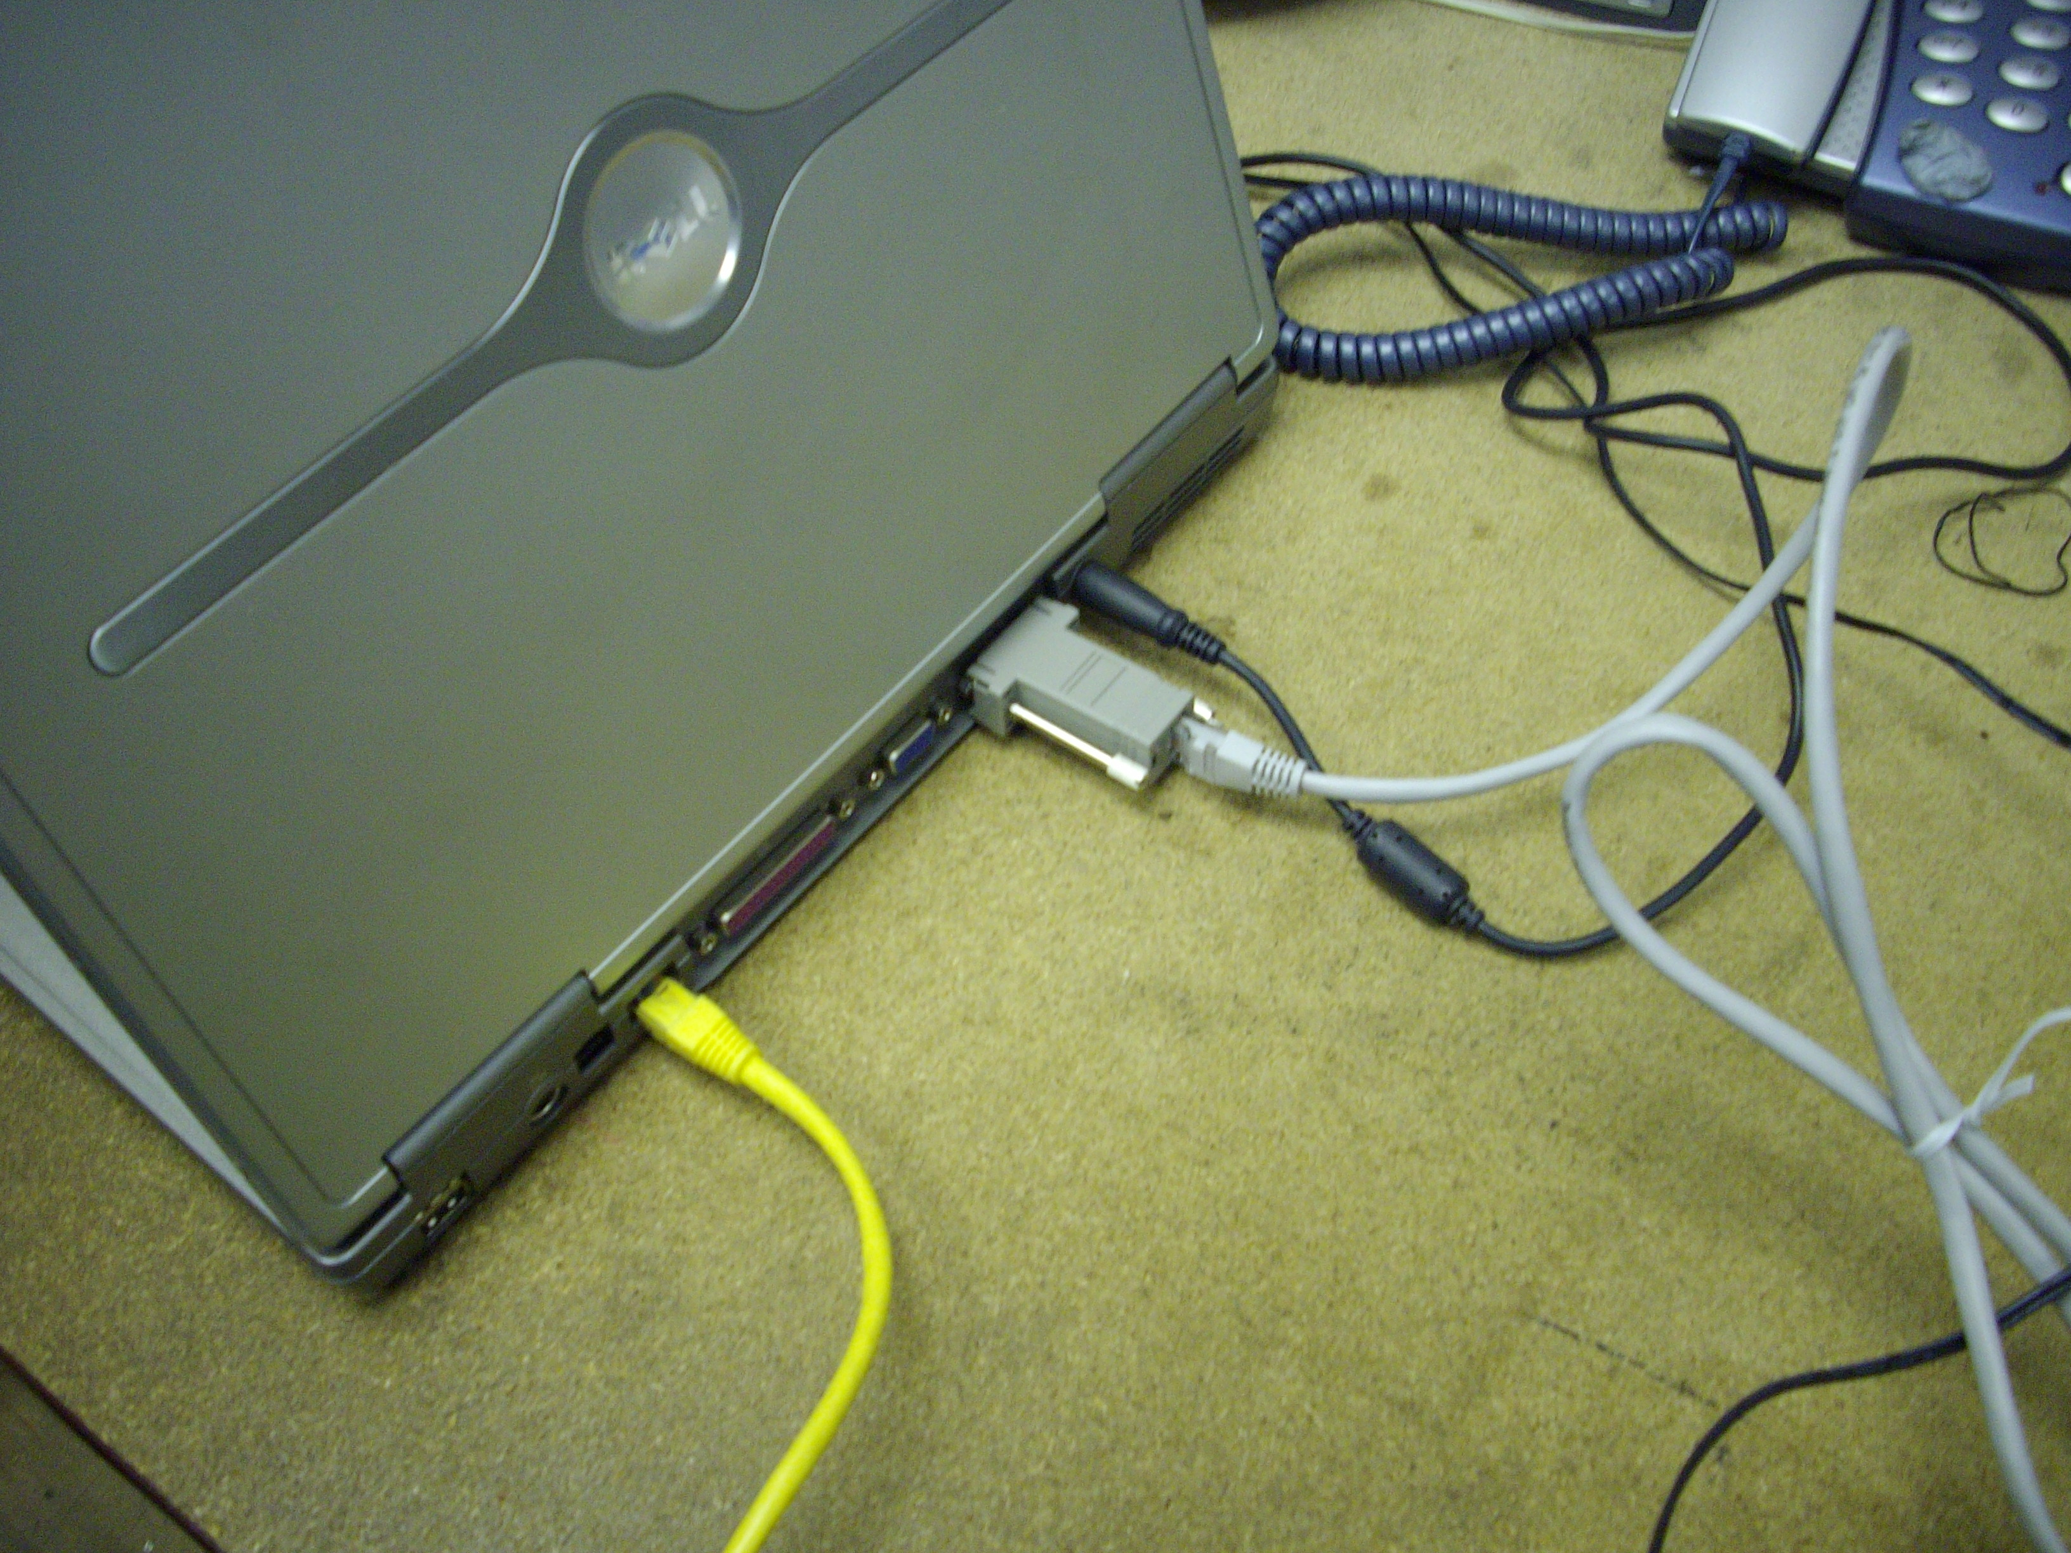

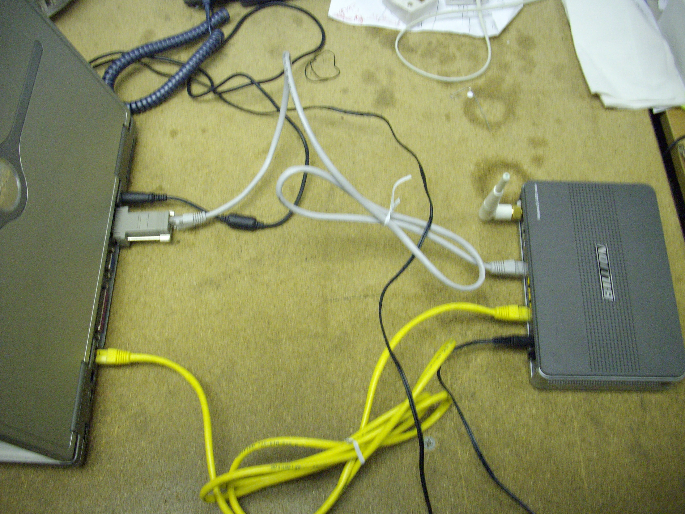

5. Start the Hyper Terminal program in windows.

It should look like below.

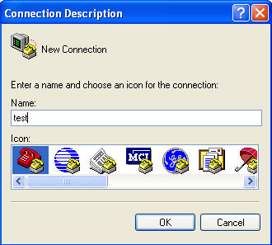

Enter test and pick any icon and click on “OK”. The next page will load and look like this.

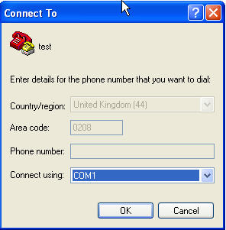

Please select “COM1” and click on “OK”
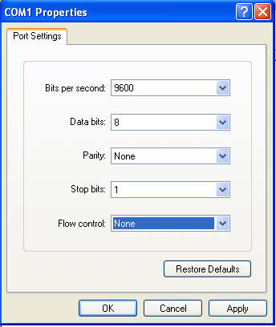

On the Bits per second please select “9600” as shown above. Also please select “None” on the Flow control and click on “OK”.

A box will appears like below. Type login User: admin Password: admin
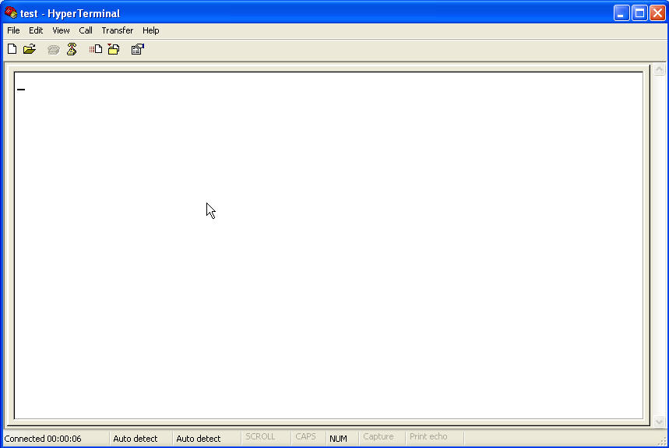

Then type “console enable” without the quotes then press enter

Then type “ppp event 5” then press enter

Then type “event show” then press enter

