7800 series emergency upgrade

- Set static IP:192.168.1.222;subnet mask: 255.255.255.0; gateway: 192.168.1.254.
- Plug PC cable into EWAN port.
- Hold the reset button and then power on the 7800 series.
- When power LED is orange, you could release the reset button.
- Open your Browser and access Web UI http://192.168.1.254
- You could see the page as below:
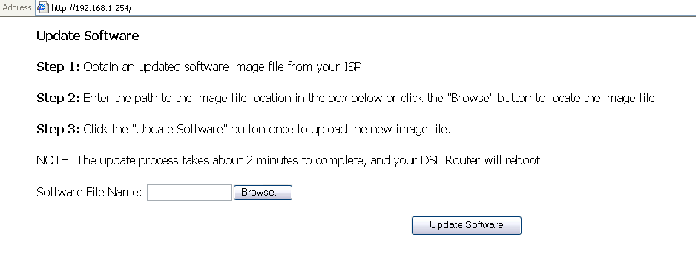
- Then please Browse your FW (1.02d.afw or other version). Press Update Software.
- You will see a message as below:
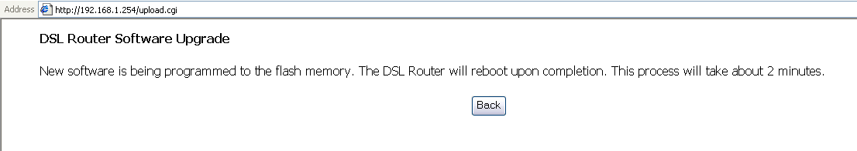
- After 2 minutes, you can access http://192.168.1.254 (Router’s LAN IP).

